***Experiment No: 10***

***Experiment Name:***

Implementation of FCFS Disk Scheduling algorithm.

***Objectives:***

In this lab we will learn about FCFS Disk Scheduling Algorithm, Implement FCFS Disk Scheduling algorithm by using c program and testing the program with different inputs and find outputs.

*First Come First Serve (FCFS)*

1. Requests are serviced in the order in which they arrive
2. The algorithm is easy to implement
3. Bad algorithm as it may involve lots of unnecessary seek distance

***Source Code:***

#include<stdio.h>

void main()

{

int queue[20],n,head,i,j,k,seek=0,max,diff;

float aver;

printf("Enter the maximum range of the disk: ");

scanf("%d",&max);

printf("Enter the size of queue request: ");

scanf("%d",&n);

printf("Enter the queue: \n");

for(i=1; i<=n; i++)

{

scanf("%d",&queue[i]);

}

printf("Enter the initial head position: ");

scanf("%d",&head);

queue[0]=head;

for(j=0; j<=n-1; j++)

{

diff=abs(queue[j+1]-queue[j]);

seek+=diff;

printf("Move is from %d to %d with seek %d\n",queue[j],queue[j+1],diff);

}

printf("Total seek time is %d\n",seek);

aver=seek/(float)n;

printf("avrage seek time is %f\n",aver);

}

***Output:***

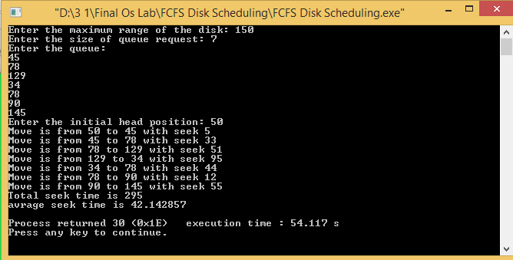

***Discussion:***

Finally in this lab we have learnt about FCFS Disk Scheduling algorithm. We also have learnt how to implement FCFS Disk Scheduling algorithm by using C program And testing the program with different inputs and find outputs.